Beflex Abs Main Video Story Board | DTX Media

This video requires multiple scenes and locations. Video will be created with a mix of product demonstrations and stock video clips.

Scene | Audio | Visuals
1  original | VO: Introducing the all new Beflex, a revolutionary core workout device designed to move with you. | model holding the beflex and smiling.
2  original | VO: The beflex quickly snaps onto your car's headrest for ultimate convenience. | 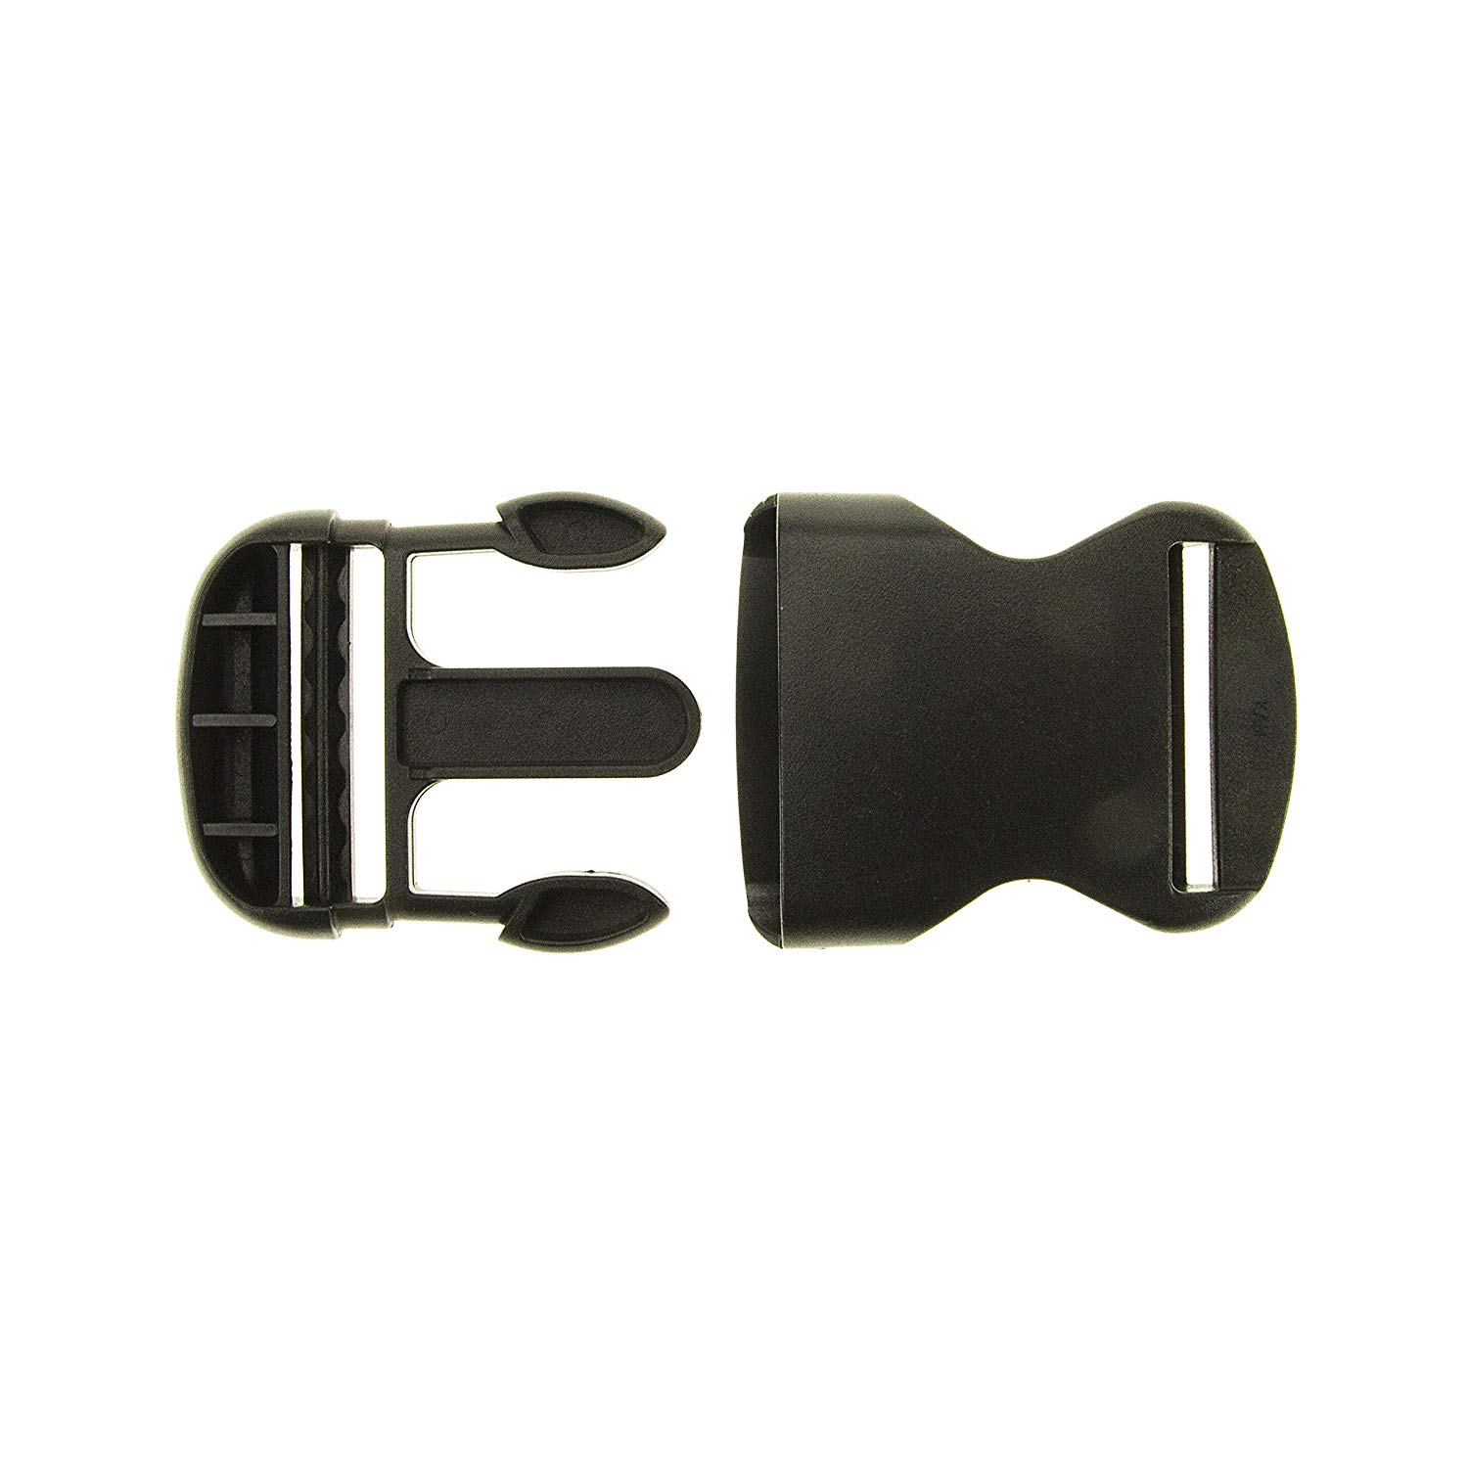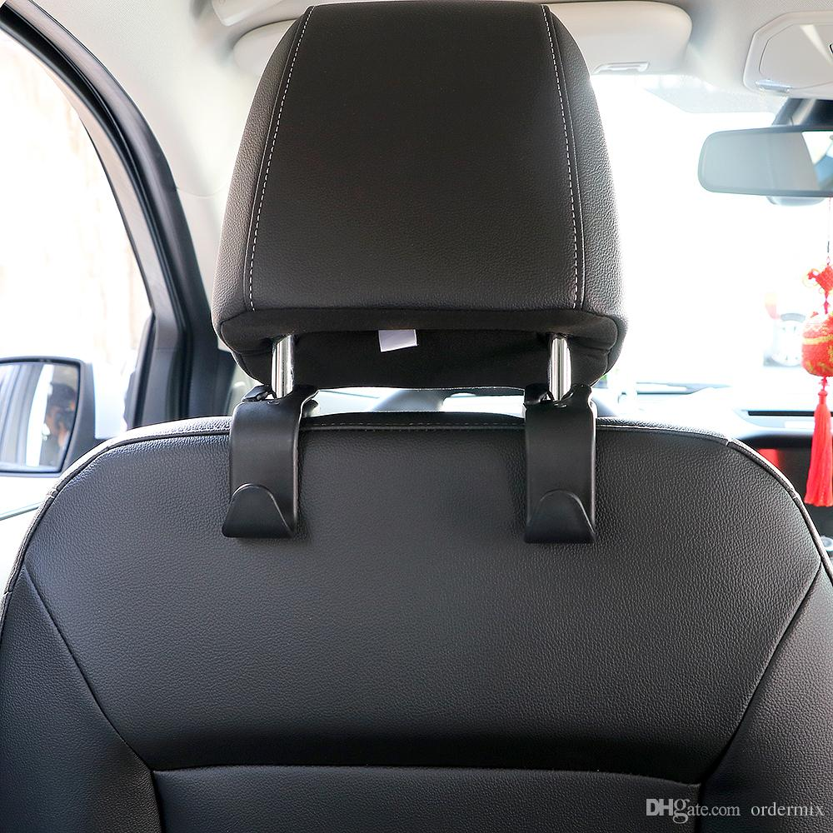  showing it clip in place
3  original | VO: Simply place the comfortable head piece on and lean forward. | 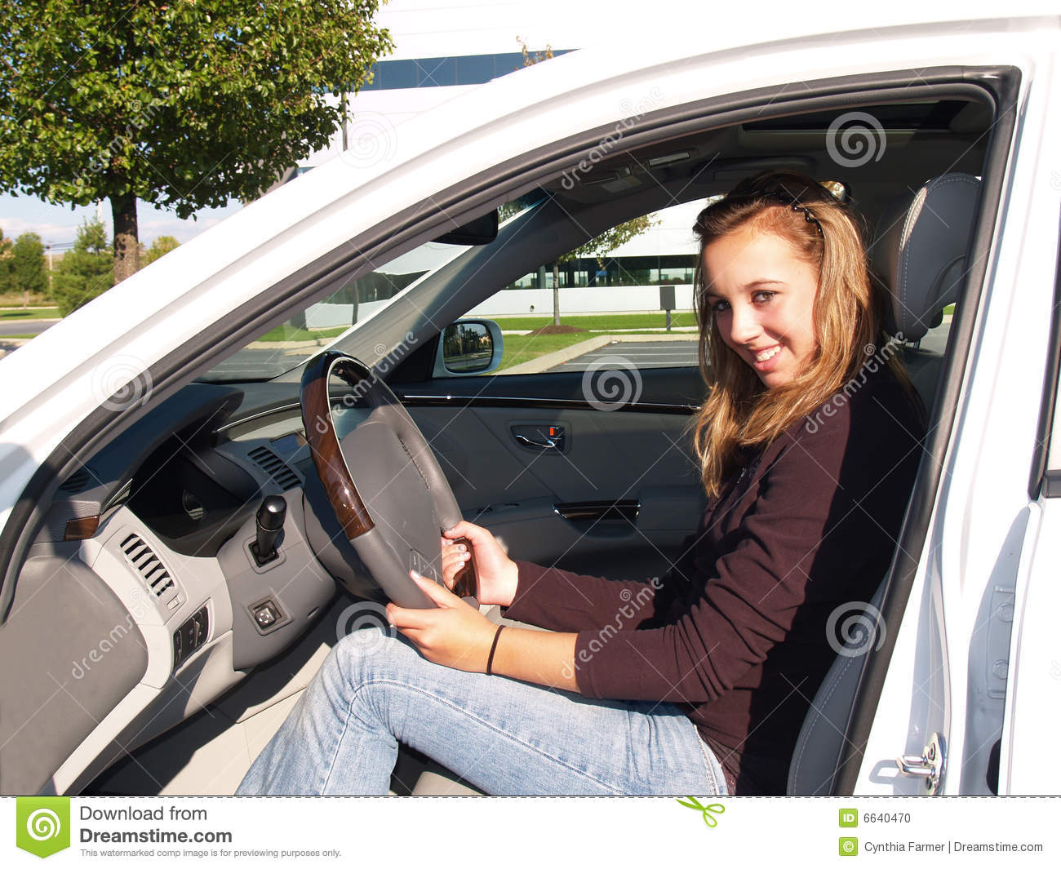  first visual demonstration of beflex
4  original | VO: Within a matter of a seconds you will start to feel the burn in your core and you hold a resisted crunch. When not in use, just flip it behind the headrest. | close up of abs, then shot of it being slipped behind
5, 6  original  original with animation | VO: Powered by high strength abrasion resistance Nylon Spandex, the high quality elastic band provides maximum resistance at the point highest point of the body, working your abs and core to their fullest. | 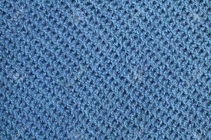  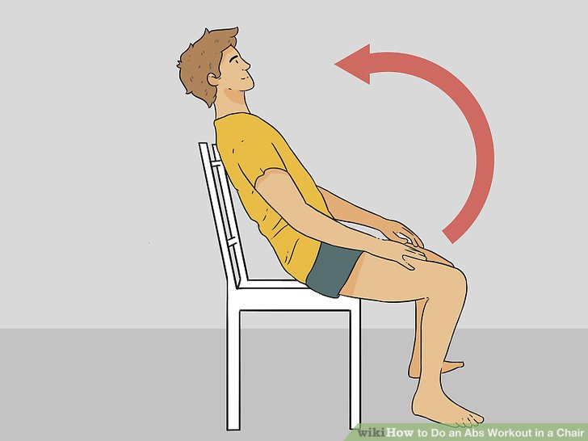  Close up of fabric / elastic stretching, followed by potentially a graphic over showing the angle of the head to
7, 8  original  original  (need kids) neighborhood | Female: I love my beflex. I use it everyday for one minute at a time while I wait in the school car pickup line. With the stomach I've been able to make, you wouldn't even know I had kids. | 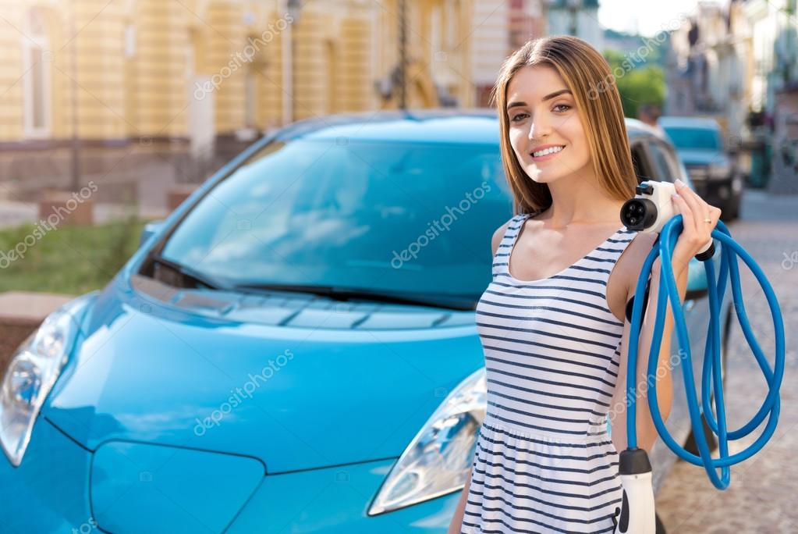  accompanied by shots of her waiting for school to get out. Or shots of kids getting in then the car.
9, 10  original  original | Male: The beflex allows me to get a quick ab workout every time I get in or out of my car without ever breaking a sweat. My six pack has never been better. | start with interview, cut to b-roll, business attire, walking into office. Smiling.
11  original | VO: Don't waste money on awkward, large or expensive machines or gym membership | 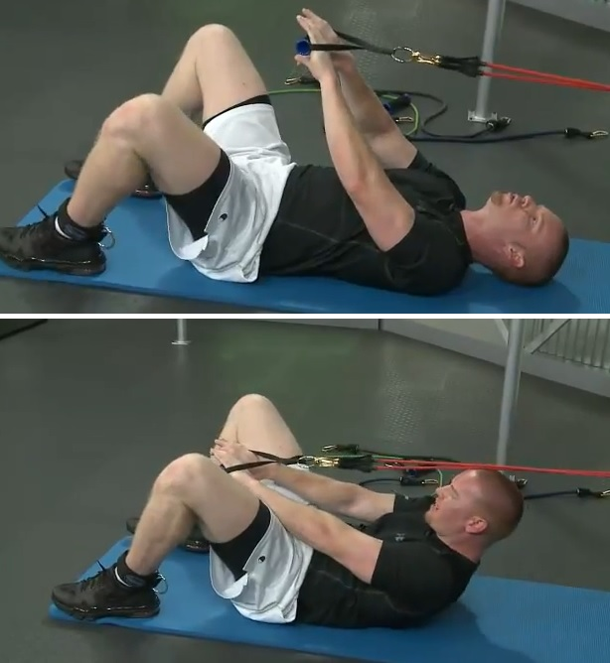  FAIL video clips.
12  original  or Stock  with animation overlays | VO: The patented beflex ab provides exercises that train not just the abs, but the the muscles in your pelvis, lower back and hips. | 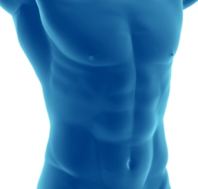  either more shot of in use, or cut to an animation that illuminated mucsles / parts of the body
13, 14 , 15  stock hiking  stock golf  stock cooking  maybe original clip of them loading car or cooking | VO: This leads to better balance and stability, whether you’re hiking, golfing or just participating in daily activities. | feel good clips living life
Small Text on screen (Credit "
Why you should strengthen your core muscles" - Mayo Clinic)

16, 17  original  stock (at beach)  https://www.pond5.com/stock-footage/94975531/group-attractive-woman-vacation-arriving-beach-car.html | VO: Whether you want to get get rid of that stubborn fat, strengthen your core, or just burn calories the beflex is the perfect companion. Order yours today and step out of the car with confidence. | 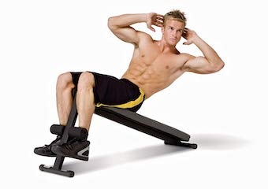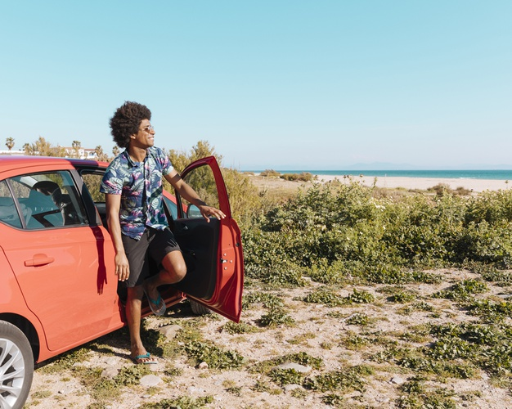  final shots of device in use. People getting out of car, or unloading beach stuff from back of car in swimsuits.
Small Text on screen:
Always consult doctor before using and any exercise device.

